

Having an ECG (Electrocardiogram)

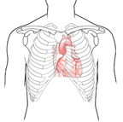

An ECG is a test to check your heart.

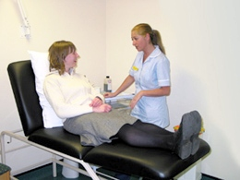

A nurse will ask you to lie on the examination couch.

Your carer or a friend can stay with you if you want.



You will be asked to take your top off.

Stickers will be placed on your chest, arms and legs.

Don’t worry it will not hurt. Just relax and lie still.

[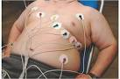](http://www.google.co.uk/url?url=http://what-when-how.com/paramedic-care/diagnostic-ecgthe-12-lead-clinical-essentials-paramedic-care-part-2/&rct=j&frm=1&q=&esrc=s&sa=U&ei=v083Va_2BIrnaqrrgcAK&ved=0CBwQ9QEwAzgo&usg=AFQjCNFymPWIKJ4ZVJLk8lUcG5wXAtRvsw)

[](http://www.google.co.uk/url?url=http://www.alamy.com/stock-photo-practice-nurse-doing-ecg-on-male-patient-in-gp-surgery-1172314.html&rct=j&frm=1&q=&esrc=s&sa=U&ei=wVE3Vdf0LMblarnkgKgB&ved=0CDYQ9QEwEDhk&usg=AFQjCNF5oYQ26XU22oaVvOsrxpoTr1DByA)

The doctor will look at the results.