Hodnet Medical Centre

A guide to our services

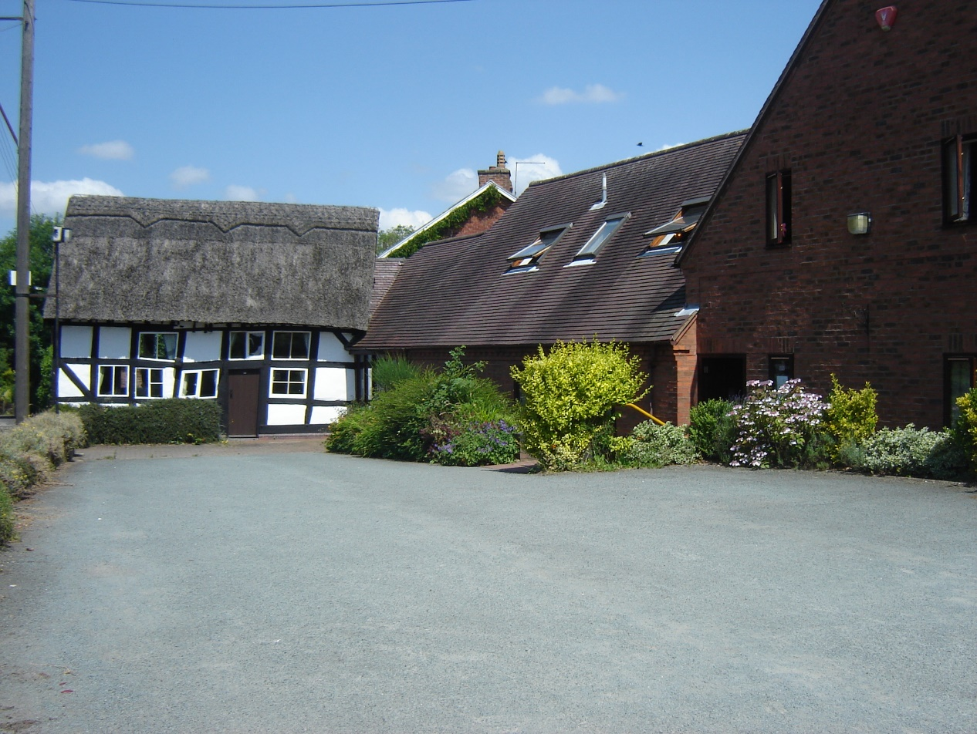

Telephone: 01630 685230

This practice is within the Shropshire Telford and Wrekin ICB area

2

Welcome

Our aim is to provide our patients with the best possible medical service. All members of the practice team will treat our patients with dignity, respect and complete confidentiality.

Hodnet Medical Practice will exist for the benefit of the patients, being responsive to their needs, whilst providing a personal efficient and friendly service.

Our list of approximately 3600 patients is looked after by our Doctors:-

Dr James Mehta MBBS. DRCOG.
Dr Sally Johnson MBChB, MRCGP, DCH

Our Team:-

Practice Nurse and HCA Team
Sister Nicola Willicombe
Sister Helen McClenaghan
Carol Borrett
Samantha Gresswell
Laura Alexe
Our practice nurse team operate a pre-bookable appointment system, and our telephonists are able to arrange appointments for you. Nurse-led disease management clinics operate for diabetes, and respiratory problems. These clinics are supervised by the doctor who is available when necessary. Telephone consultations are available by contacting the practice.
The practice nurses and Health care assistant are able to carry out a range of procedures including blood taking, dressings, injections, routine immunisations, ear syringing, spirometry and ECGs. In addition they can offer advice on diet, and lifestyle. Patients are seen by the nurses by appointment only.
Dispensary/Reception Staff

Christine Poole is the Dispensary Manager.
Angela Beckett, Dispenser
Jessica Turner, Dispenser

A dispenser or receptionist is always available to assist you in registering for on line ordering of repeat medication.

Reception & Administrative Staff

Becky Ross and Janice Owen are our administrative staff. Alongside dispensing staff they deal with booking appointments, patient enquiries, clerical and dispensing queries and the management of your medical records, all whilst maintaining complete confidence. The role of the receptionist is extremely demanding, - please be patient!

Practice Manager

Rosemary Mehta is our Practice Manager. With a background as a primary school teacher prior to joining the practice, she now has many years of experience working across all areas of the practice.

Deputy Practice Manager

Michelle Holland is our deputy practice manager. Michelle has many, many years experience of working at the practice- her entire working life -and knows all aspects of the practice.

Medical Secretary

Sharon Worrall is our experienced medical secretary and senior staff member. Sharon deals with referrals and all aspects of admin.

Community Health

We are supported by a Community Health Team, which includes, District Nurses, a Midwife, and a Health Visitor who will treat people in the community if necessary.

The team is based at Market Drayton Primary Care Centre. Patients already on the District Nurses’ caseload can contact them directly by telephoning 01630 650734. New patients need to be referred by a GP.
Health Visitor
Our Health Visitor offers advice on the health of mothers and babies, children, the elderly and the handicapped. She is based at Market Drayton Primary Care Centre can be contacted during working hours on 01630 685545
Community Midwife
The Community Midwife undertakes maternity care with your doctor. Messages may be left at Market Drayton Primary Care Centre by telephoning 01630 650727. The Community Midwife, who will discuss all aspects of your antenatal care with you.

Our administrative and dispensing staff between them deals with appointments, patient enquiries, clerical and dispensing queries whilst maintaining complete confidence.
The staff of the Medical Centre are here to help you. Please be patient when they are busy. Should you have any queries or suggestions about non-medical aspects of your care, please ask to speak to the practice manager (Mrs R Mehta).
We aim to treat all our patients promptly, courteously and in complete confidence.
Attending a busy GP surgery can be an anxious and worrying time for you. We aim to make your time here as short and as simple as possible. The following should help to explain what you, as a patient can expect from our staff and what we, the staff, can expect from you.
Your Doctor's Responsibilities:
1. To treat you with respect and courtesy at all times.
2. To treat you as an individual, and to discuss with you the care and treatment we
can provide.
3. To give you full information on the services we offer.
4. To give you the most appropriate care by suitably qualified staff.
5. To provide you with emergency care when you need it.
6. To refer you to a suitable consultant when necessary.
7. To give you access to your health records, subject to any limitations in the law.

Your Responsibilities As A Patient:

1. To treat all staff with respect and courtesy at all times.
2. To tell us if you are unsure about the treatment we are offering you.
3. To ask for a home visit, only when you are unable to attend the medical centre
through illness or infirmity.
4. To request such a visit if at all possible before 10.00am.
5. To ask for an out-of-hours visit only when necessary.
6. To keep your appointments and contact the medical centre in advance if you
cannot attend.
7. To respect the premises which was built with you

If you live in our practice area and would like to register with us, please complete a registration form (available from reception). You will be registering with the practice rather than an individual GP, however you will be able to say which doctor you wish to see when you book an appointment.
Appointments
Please ring our main telephone number (01630 685230) to book an appointment. Or use patient Access to book online.

Surgery Times

Morning open surgeries are held without pre-booked an appointment. Please phone between 8.30 - 9.45am, Monday – Friday to request a telephone call back from a clinician. If the clinician feels you need to be seen face to face they will arrange this with you during your telephone consultation.

Afternoon surgeries are by appointment only, and are held on Monday, Tuesday, Wednesday, and Friday, generally commencing at 2pm, with the last appointment at 5pm. There is no surgery held on Thursday afternoon. This time is spent doing Nursing Home rounds and admin generated through the week.

Opening Times

Monday 8.30am – 1.00pm 2.00pm – 6.00pm
Tuesday 8.30am – 1.00pm 2.00pm – 6.00pm
Wednesday 8.30am – 1.00pm 2.00pm – 6.00pm
Thursday 8.30am – 12.30pm CLOSED to routine patients- Nursing home rounds and admin take place on Thursday afternoons
Friday 8.30am – 1.00pm 2.00pm – 6.00pm

Surgery Appointment Times

Morning surgery – weekdays 8.30 – 9.45am.
(Please ring to request a same day call back).

Afternoon booked surgery –
Monday, Tuesday, Wednesday, and Friday, (2.00 – 6pm).
(You must have an appointment)

Contacting a Doctor when the surgery is closed

If you should require urgent medical attention outside normal surgery hours, simply telephone the surgery on 01630 685230, to hear an outgoing message which will direct you to telephone 111. Your call will be answered, and the call handler will take some basic details from you. A doctor will then ring you back, and may:-

- give advice
- arrange an appointment with a doctor at one of the Primary Care Centres, or
- arrange a home visit if you need to be seen and are not fit enough to travel. For example, very elderly/bed-bound patients, terminal care cases, and those where a move might make the condition worse.
- call an ambulance to transport you to hospital
- arrange for a District Nurse to visit you.

Alternatively, you may attend the Accident/Emergency Department at Princess Royal Hospital or Royal Shrewsbury Hospital

Accident and Emergency – 999

If you experience severe chest pain, loss of blood or suspected broken bones, go to your nearest accident and emergency department or call 999.

EMIS Patient Access

Accessing Medical Information Online
You can now access parts of your medical record on line.
As well as being able to book appointments and order prescriptions you will be able to see a list of your medication, immunisations and any allergies you may have.
Please ask at the surgery to join up to this service.

Violent or Abusive Patients
The practice will not tolerate violent or abusive behaviour. Anyone verbally abusing either a member of staff or the public, or using inappropriate language, will be asked to leave the premises and requested to find another GP. Anyone who is violent or causes damage will be removed from the practice list immediately.

Telephone advice

Sometimes a telephone call will avoid the need for a consultation. If you wish to speak to a doctor or nurse about a matter, telephone the surgery on 01630 685230, and you will be advised to either ring again at a specific time, or your telephone number will be recorded in order for the appropriate person to return your call.
Home visits
Our doctors typically see at least four patients in the practice in the time it takes to do a single home visit. For this reason we ask our patients to come to the surgery if at all possible. However, we can visit at home if your condition means you cannot attend the practice. Please ring before 10am to speak to a doctor if you feel your condition is urgent.
Sick notes

You do not require a Doctor's sickness certificate for any illness lasting seven days or less. Your employer may however require you to complete a self certification form (SC2) which is available from your employer or on the HMRC website www.hmrc.gov.uk/forms/sc2.pdf
If you still require a private medical certificate you will be charged for this, in line with the current fees recommended by the BMA.

Dispensing

Hodnet is a dispensing practice, where most patients are able to obtain their medicines direct from the surgery. This facility is dependant upon your address. If
you live within one mile of a pharmacy, then it will not be possible to dispense your medication from the surgery. If you require regular medication you may arrange to receive repeat prescriptions after discussion with your Doctor. Please remember to mark the items that you require.
You can also order online using either Hodnet Medical Centre website or www.patient.co.uk , or submit your request by post. Please allow at least three working days between ordering and collecting. (Please note Thursday is a half day) After a given number of repeats, you may be asked to see your doctor for a review.
New patients must be seen by the doctor before medication can be prescribed.
We are not able to accept requests for repeat prescriptions by telephone.

Results of tests and x-rays

Please telephone 01630 685230 between 11am-12 noon on weekdays to request your results.

The telephonist will be able to give you your test results, provided they have been seen and acted upon by the GPs. We cannot give your results to any other member of your family or a friend so please do not ask them to ring on your behalf. The telephonist may need to check your identity if you are asking for a result. Please do not be offended; it is to protect your privacy. Results of routine blood tests are available after 4 days, urine tests 5 days and X-rays 7 - 10 days (excluding weekends)

Other services

Cervical smear screening

Cervical smear clinics are held by Sr Sehra Mehta, and are by appointment only.
Disease prevention and monitoring clinics
Regular clinics to detect and monitor certain chronic diseases such as diabetes and asthma are run by Sr Willicombe.
Asthma
Asthma sufferers are invited to attend for annual review by the practice. Advice and support is offered by our practice nurse, and Sr Willicombe. Patients are also offered spirometry. Unfortunately many of these patients continue to smoke. Smoking cessation advice is also available. All Asthmatic patients should consider having an annual 'Flu injection.

Diabetes

This clinic offers general advice and monitoring to patients suffering from diabetes. Patients are invited to attend for annual review, and a specialist diabetic foot care clinic appointment is also offered.

Travel vaccination advice
We are no longer able to provide a comprehensive travel service at the medical centre. This is a highly specialised non-NHS service, and due to increasing demands on the practice, we are unable to maintain this service. We will however, continue to provide the following travel vaccinations which are available on the NHS.

Hepatitis A
Typhoid
Cholera (this vaccine is not indicated for most travellers)

It is important when travelling abroad that you have the appropriate travel advice and vaccinations. Antimalarial over the counter medication may be purchased from retail pharmacies. You can get information from a number of websites but we would recommend you visit www.masta-travel-health.com or NaTHNaC nathnac.net which offer advice and the latest information on the recommended vaccinations for the country you are visiting.

If you need other vaccinations which are not available under the NHS, you will need to contact a private travel clinic who will advise you of the fees involved.
Private Medicals and Reports
Certain medicals, reports and forms are not covered by the NHS. These will be charged at the BMA recommended rate. Please ask at reception, visit our website or telephone the surgery for details.
Disabled Patients
Hodnet Medical Centre has full disabled access and facilities. Guide and Assistance dogs are welcome. If there is anything we can do to assist you please let us know and we will be more than happy to help.

Patient Participation Group

The PPG has been established and has been registered with the National PPG Scheme. The aim of the group is to improve communication between the Practice Team and the wider community and to seek patients’ views so that these might be taken into account when deciding how we deliver existing services or develop new services.

The group has plans to meet 3 or 4 times a year. The group members are as follows:

Richard Holtom - Chairman
Mary Hardy - Secretary
Cllr Karen Calder
Helen Charnock
Christine Poole (surgery representative)
Jennifer Kelleher
Sandra Williams
Tory Russell

New members are always welcome. We aim to have members who represent all groups across our community (eg Men/women, old/young, working/not working, variety of ethinic groups). Please contact Rosemary Mehta or Michelle Holland if you are interested in joining the group.

Complaints:-

Hodnet Medical Centre aims to give a friendly and professional service to all our patients. However, if you have any concerns about any aspect of our service, please let us know. Speak to whomever you feel most comfortable – your GP, our practice manager or our reception staff will be happy to help. Alternatively you may wish to write to us or fill in a complaint form which are available tat reception. In the majority of cases, concerns can be resolved quite easily. However, if you feel we have not dealt with the issues you have raised, as you would wish, you can write to

The Complaints Manager (this dept. has replaced PALS from April 2013)

NHS England

Shropshire and Staffordshire Area Team

Anglesey House

Wheelhouse Road,

Towers Plaza,

Rugeley,

Staffordshire, WS15 1UL

Data Protection
The practice uses computers in many aspects of its day-to-day activities. The computer is used during consultations as it enables us to keep your records up to date and helps us maintain an efficient register of all of our patients. It is an invaluable tool in preventative medicine, screening and education. The practice is registered under the Data Protection Act and strict confidentiality is maintained at all times.
This practice uses EMIS Software, a computerised medical record system. Storing records on the computer can help us to monitor and audit our performance so that we provide the best possible care. Your registration details are held on the computer, along with the medical information from consultations. Anonymised health information is sent to Shropshire CCG to monitor quality standards and for post-payment verification purposes.

Protection and Use of Your Information

We ask for information about yourself so that you can receive the best possible care and treatment. We keep this information, together with details of your care, to ensure that your doctor or nurse has accurate and up to date information it may also be needed if we see you again.

We only use or pass information about you to people who have a genuine need for it. Whenever we can we shall remove details that identify you as an individual.

Everyone working for the NHS has a legal duty to maintain the highest level of confidentiality about patient information.

For further information please refer to the leaflets held in reception entitled “Your Records are Safe with Us”

